Fuzhou University (FZU) Campus Architecture
Iconic Buildings and Landmarks

1. Fuzhou University Main Gate
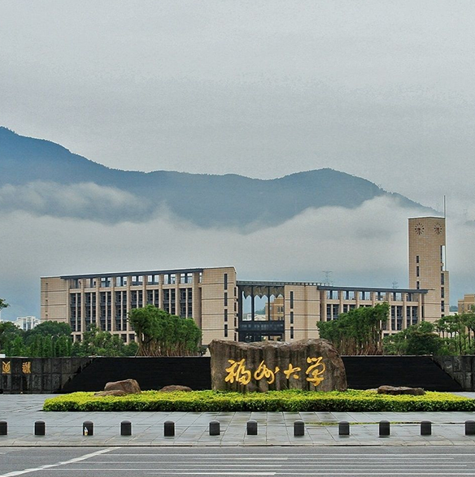
Fuzhou University Main Gate
The main gate of Fuzhou University (Qishan Campus) serves as the iconic entrance to the university. Featuring the university name inscribed on a grand stone monument, it embodies the university motto 'Ming De Zhi Cheng, Bo Xue Yuan Zhi' (Illustrious Virtue and Absolute Sincerity, Broad Learning and Lofty Aspiration). The gate stands as a symbol of the university's heritage and academic excellence since its founding in 1958.

2. Fuzhou University Library
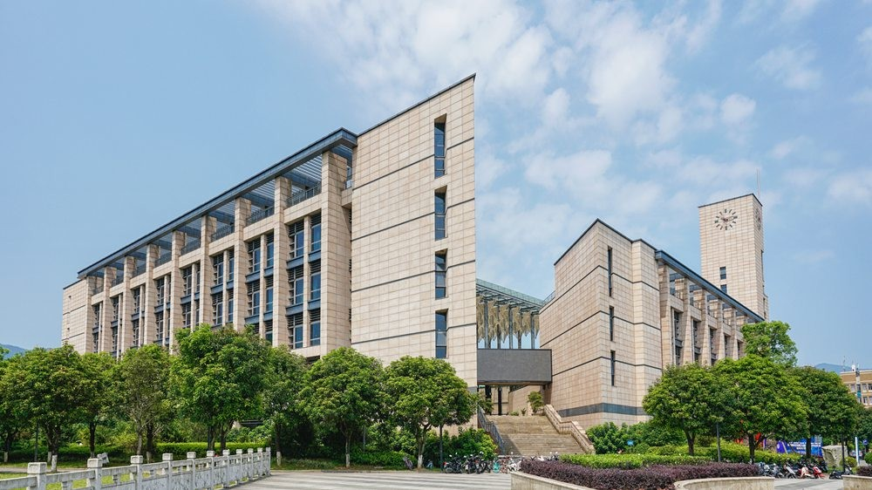
Fuzhou University Library
The Fuzhou University Library is an award-winning architectural masterpiece, recipient of the prestigious Luban Prize (China's highest construction award) in 2008. Located at the campus center, this 35,500 m² modern building features a distinctive square design inspired by traditional Fujian tulou architecture. Housing over 3.8 million printed volumes and 9.3 million e-books, it stands as one of China's Top 50 Most Beautiful University Libraries.

3. Jinjiang Building
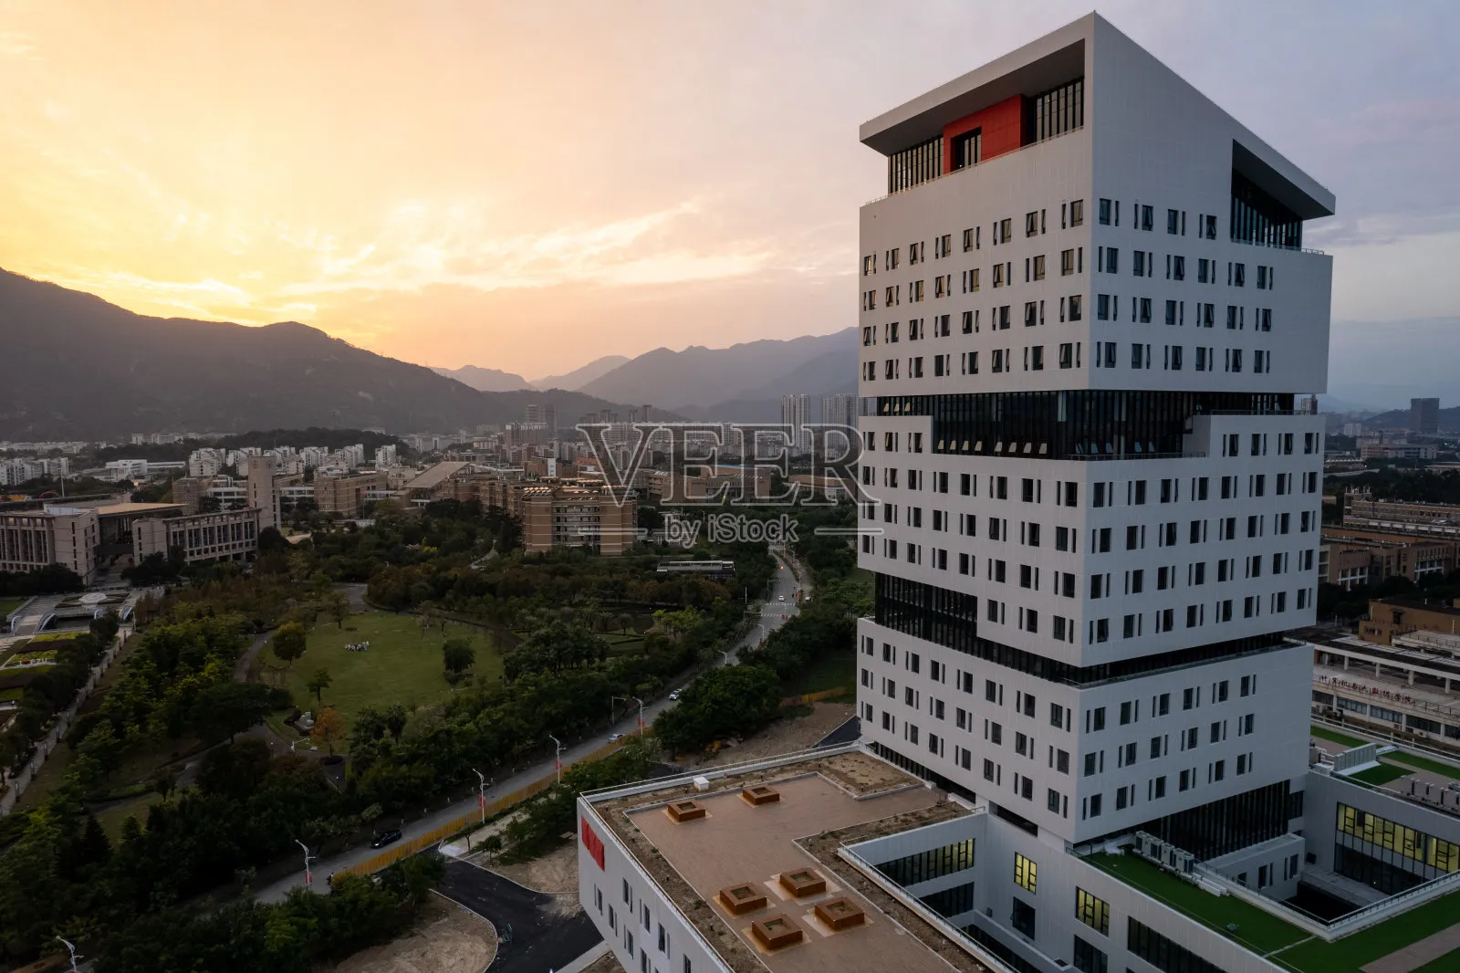
Jinjiang Building
Jinjiang Building is the landmark 100-meter tower located at the east entrance of Qishan Campus. As a symbol of university-local government collaboration, this state-of-the-art research complex houses graduate research facilities, academic exhibition halls, and the University History Museum. Its modern architectural design embodies the principles of freedom, rigor, cultural heritage, and spatial harmony.

4. Fuyou Pavilion
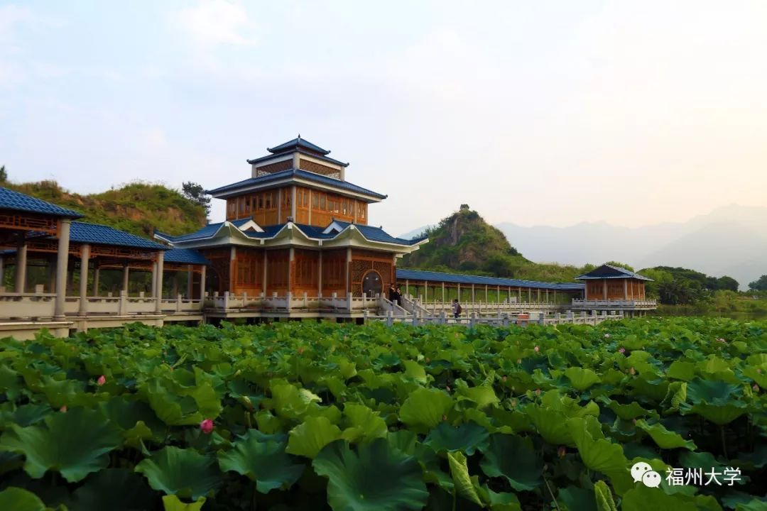
Fuyou Pavilion
Fuyou Pavilion is a traditional Chinese-style pavilion situated by the campus lake, surrounded by lotus ponds and scenic landscapes. This elegant structure serves as a creative hub and maker space for students, combining classical Chinese architectural aesthetics with modern innovation functions. Its name, derived from 'Cultivating Virtue and Fostering Friendship', reflects the university's humanistic spirit.

5. Honghui Sports and Culture Complex
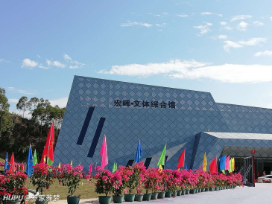
Honghui Sports and Culture Complex
Honghui Sports and Culture Complex is a multi-functional venue integrating sports facilities, auditorium spaces, and cultural activity centers. Located near the south campus gate, this modern geometric building hosts graduation ceremonies, academic conferences, sporting events, and artistic performances. Its distinctive angular design symbolizes the perseverance and determination of FZU students.

6. FZU Campus Lake View

FZU Campus Lake View
The scenic campus lake at Fuzhou University offers breathtaking views with building reflections creating perfect mirror images on the water surface. Surrounded by lush greenery and set against the backdrop of mountains, this natural landscape provides a serene environment for study and relaxation. The harmonious integration of architecture and nature exemplifies FZU's beautiful campus environment.

About Fuzhou University
Fuzhou University (FZU), founded in 1958, is a key national university under the Double First-Class initiative and the 211 Project. Located in Fuzhou, Fujian Province, FZU has developed into a comprehensive research university with strengths in engineering, science, and technology. The Qishan Campus, featured in this document, showcases modern architecture harmoniously integrated with natural landscapes, creating an ideal environment for academic pursuit and innovation.

